Milliken Christian Community Church 美堅華人基督教會
Jesus Academy Summer Day Camp 2022兒童夏令日營
Registration Form 註冊表格
(For Grade 1 -6 適合一至六年級) $100 dollar per week (nonrefundable 恕不退款)
Date 日期: 11-15/7/2022; 18-22/7/2022 (9:00am – 4:00pm) (Limited Space, 額滿即止)
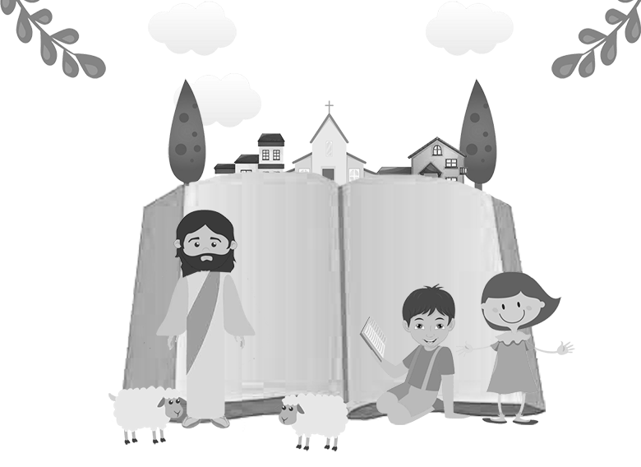
Bible Stories

Lego Robotics

Fun Based Math and Language Activities
Crafts and Games

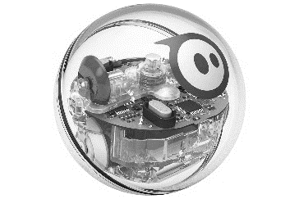

Child’s Name 孩子姓名: _________________________(表格請以英語填寫) Gender性別: Male男 _______ Female女: ______

Grade 年級: *____ (as in Sep 2022年9月新學年計) Date of Birth 出生日期: (D 日)___ / (M月)____ / (Y年)______

Address住址_________________________________city市_____________________postal code郵碼______________

Email Address 電郵: _______________________________

Legal Guardian Name監護人姓名: 1. _____________________Relationship to Child 關係: ______電話:_________________________

Legal Guardian Name /監護人姓名: 2. _____________________Relationship to Child 關係: ______電話:_________________________

Authorized Pick up Persons Names other than Guardian 受權接送人名字: 1.______________________________________

Affiliated Church 所屬教會: ________________________ Contact Person from MCCC 美堅聯絡人: ____________________
(Priorities will be given to children not currently affiliated with any church. Please understand we may not be able to accommodate those who attend other churches regularly; 我們歡迎未有故定教會之家庭參加；若在美堅以外有故定教會之家庭，恕本夏令營未能有足夠營位收錄貴子弟)

Medical & Emergency Information健康及緊急情况需要資料

Emergency Contact Name: ______________________ Phone # 電話: ______________________________
緊急事故聯絡人姓名(if different from above)
Please let us know if there is anything else we should know about your child.
如果您的孩子在體能或情绪上需要特殊照顧，請先通知，以便作出適當的處理。
____________________________________________________________________________________________________

Allergies敏感: _______________________________________________________________________________________

During Day Camp, we will be bringing your child for outdoor activities in the vicinity of our church, as well as in the nearby Parks. We also have 2 trips planned on July 15 and July 21. Details listed below.

Also, things to bring to camp for your child daily include: water bottles, snacks, lunch, hat, and sunscreen. All items must be labeled with names.

Allergy alert: if your child has severe allergy, please provide us with a recent photograph of your child so that we can post his/her image to alert camp leaders. 如有嚴重過敏反應者請預備相片以作內部識別之用。
Failure to give us the consent below will result in your child missing out on listed activities please read and sign.

MCCC Jesus Academy Day Camp 2022 Activity and General Consent 外出活動及免責條款確認

- [ ] I consent to have my child participate in outdoor activities in the vicinity of Milliken CCC, Steeles Library and the nearby David Lewis and Terry Fox Park; and the checked ✓activities below. 我同意子女參加以下加有✓號之活動。
[ ] July 15 to J. P. Tudhope Memorial Park, 450 Atherley Rd, Orillia (Transportation will be provided)
[ ] July 21 Treetop Trekking Stouffville, 3291 Stouffville Road, Stouffville (Transportation will be provided)
- I hereby give my permission for my child to attend and participate in the full Summer Day Camp Program at MCCC.
- I authorize the program organizer or its representatives to administer medication(s) to my child according to prescription instructions.
- In case of emergency, every effort shall be made to contact myself or the guardian of my child. However, in the case that we are not available, I hereby grant permission to send my child to an emergency medical care facility.
- I agree to waive any rights and all rights and claims for damages that I or my spouse may have against Milliken Christian Community Church, the program organizer and its agents, employees and representatives for any and all injury, damage, or loss sustained by my child arising directly or indirectly from the program/activity. I understand that the activity in which my child is engaging may involve a risk of injury and I knowingly and voluntarily assume such risk of injury.
- I further agree to fully indemnify and hold the activity sponsor and its agents, employees and representatives harmless from any and all claims for injury, damages or loss that my child may sustain arising directly or indirectly from the program/activity.
- I authorize videotapes, photographs and or slides to be taken of my child for the purpose of education or promotion of church activities. It is understood that my child’s name will not be used with the photos/videos/slides.
- I affirm that I have the right to authorize and agree to the foregoing. I have carefully read and understood this agreement, and have willingly placed my signature below as evidence of my acceptance of all the conditions contained herein.

Print Name of Parent / Guardian: 家長/監護人名字: __________________________

Signature of Parent / Guardian: 家長/監護人簽名: ____________________________Date: ________________2022

Milliken Christian Community Church 390 Bamburgh Circle, Scarborough, ON. M1W 3X3 Tel: 416 498 3399
Pastor Tim Yuen Tel: 416 709 1313, Email: mccc.timy@gmail.com

For Office Use Only 只供教會內部使用
Payment付款方法: Cheque/Cash/______________________________________________________
Amount Received: __________________________ Date Received收款日期: ______________________________
Week of July 11 – 15, 2022 Week of July 18 – 22, 2022

Processed by: 1.___________________________ 2.____________________________ Ref #: _____________

